SLIDE 1

In this experiment, you will see pictures that have a piece missing.

Below each picture, you will see eight pieces that can fill in the missing part of the picture.

You should look at each piece carefully, and choose the one that best completes the picture.

There is only one correct piece for each picture. If you believe that more than one answer is right, choose the best one.

Please click the mouse to continue.

SLIDE 2

On the next screen is the first practice example.

The top part of this problem is a pattern with a piece cut out of it.

Look at the pattern, think what the missing piece must be like to complete the pattern correctly, both along and down, and then find the right piece out of the eight pieces shown below the picture.

Only one of these pieces is perfectly correct.

Click on the answer you think is correct.

Please click the mouse to continue.

SLIDE 3 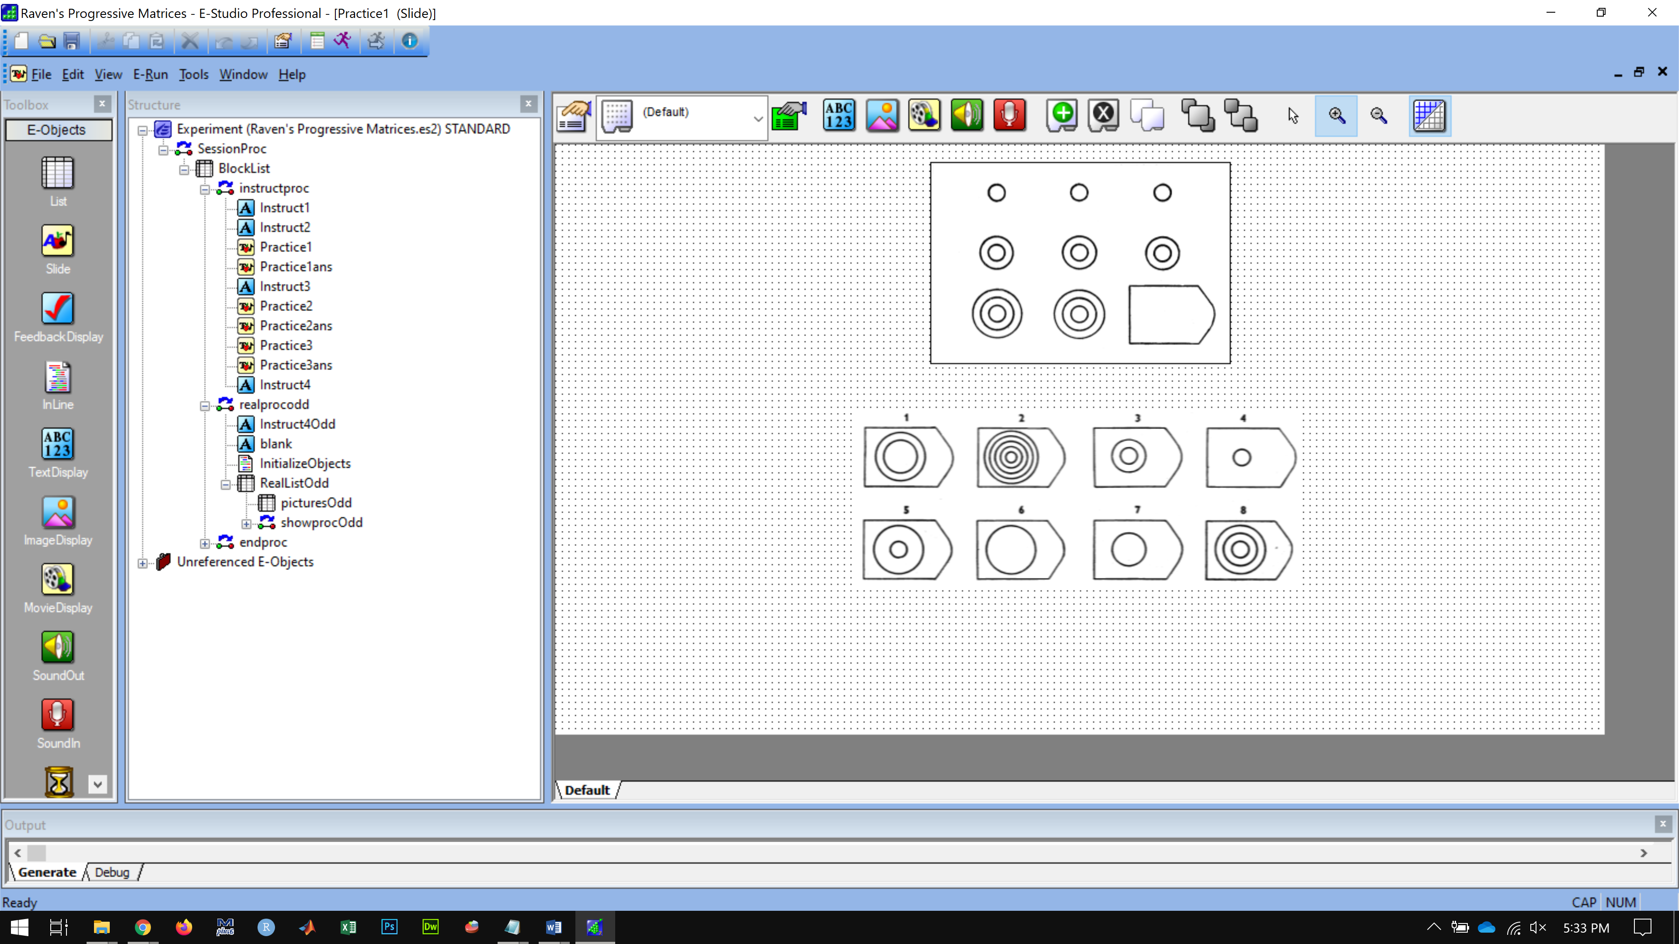

SLIDE 4 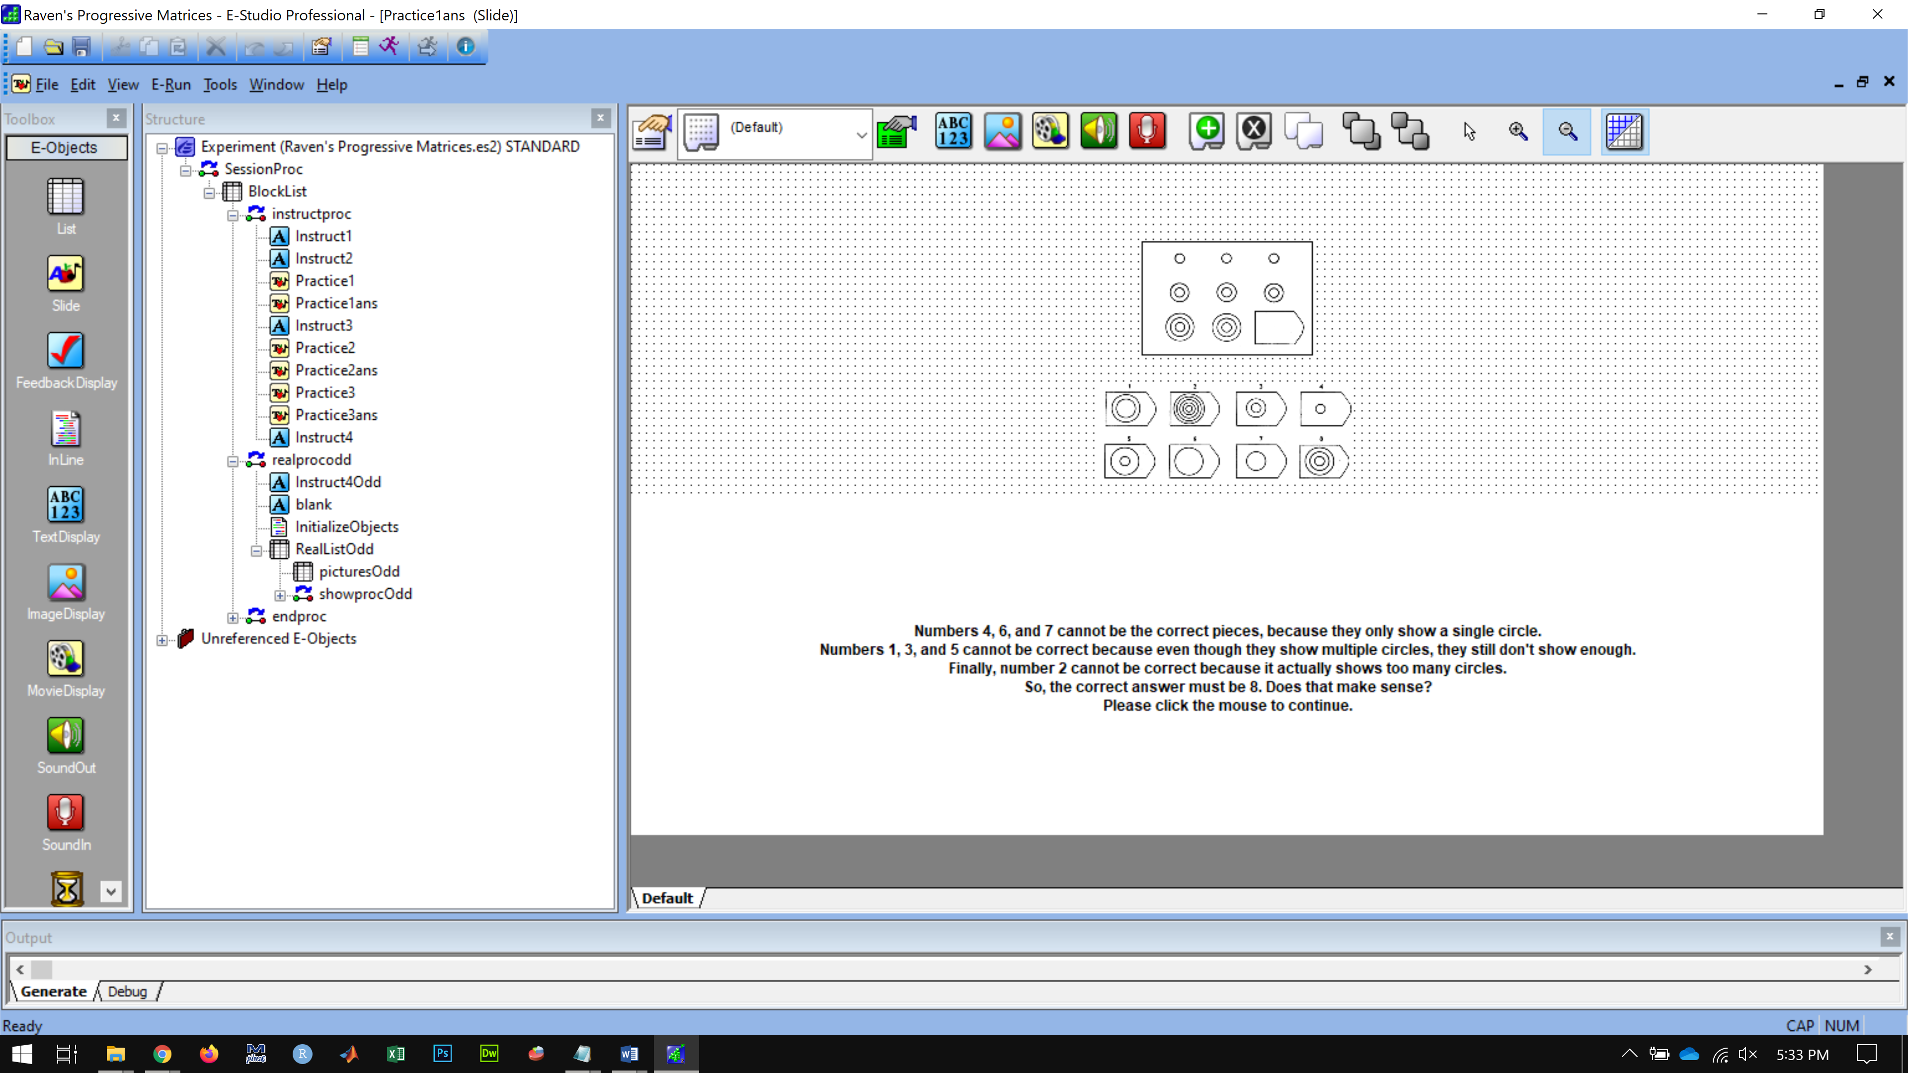

SLIDE 5

On the next screen is the second practice example.

Again, look at the pattern, think what the missing piece must be like to complete the pattern correctly, both along and down, and then find the right piece out of the eight pieces shown below the picture.

Click the mouse to continue.

SLIDE 6

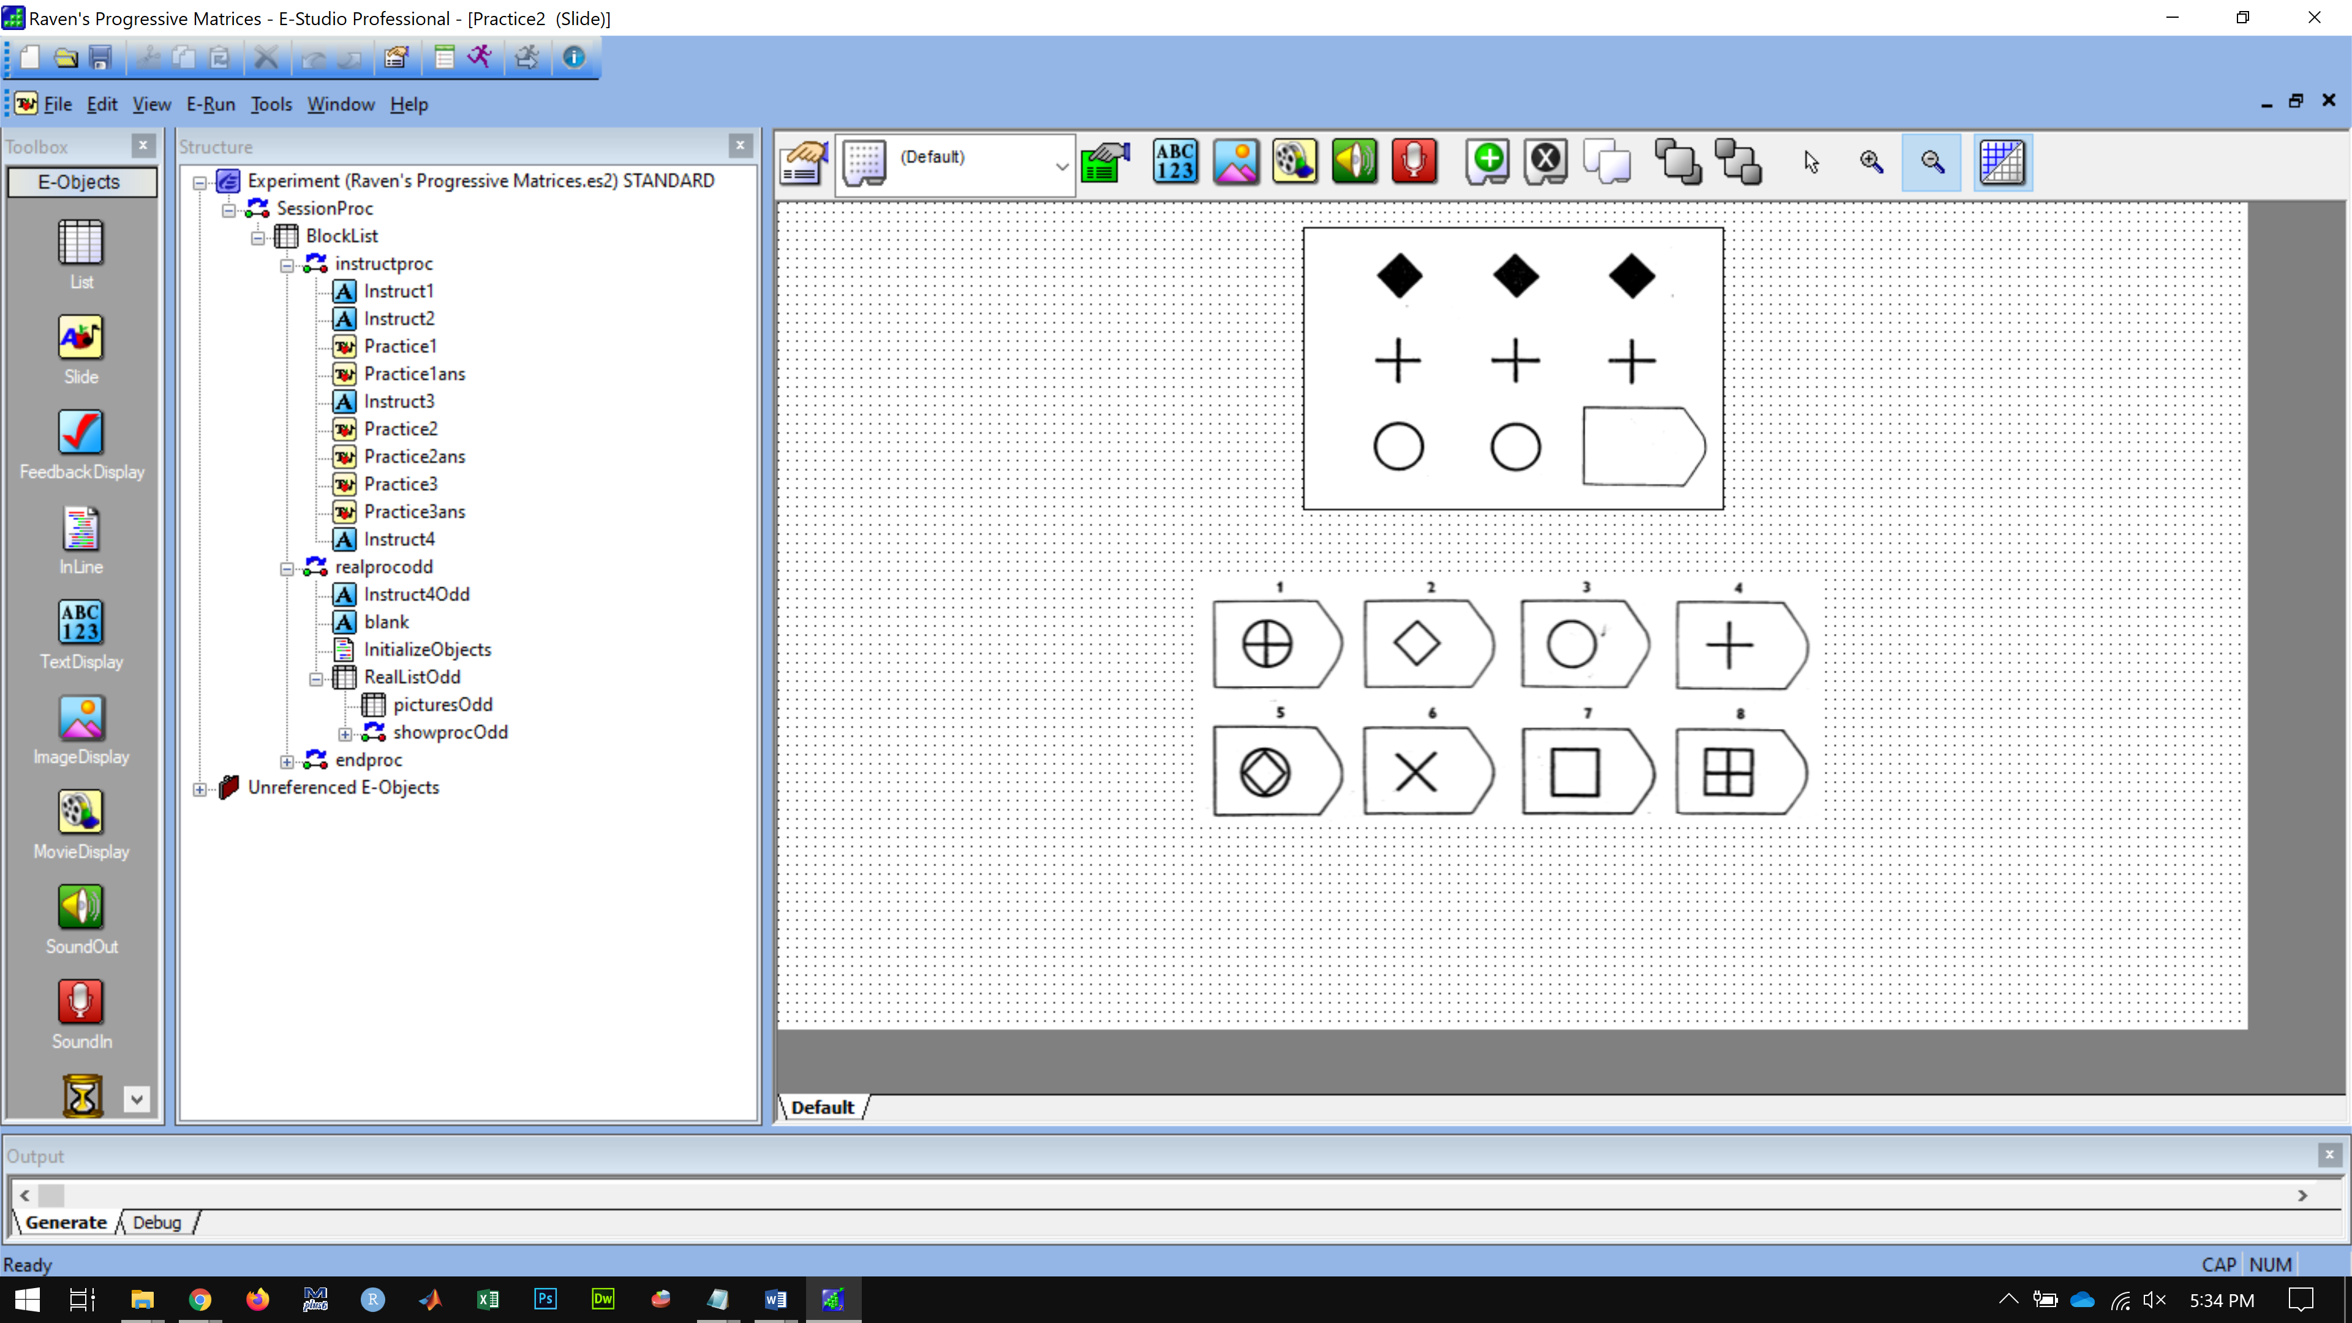

SLIDE 7 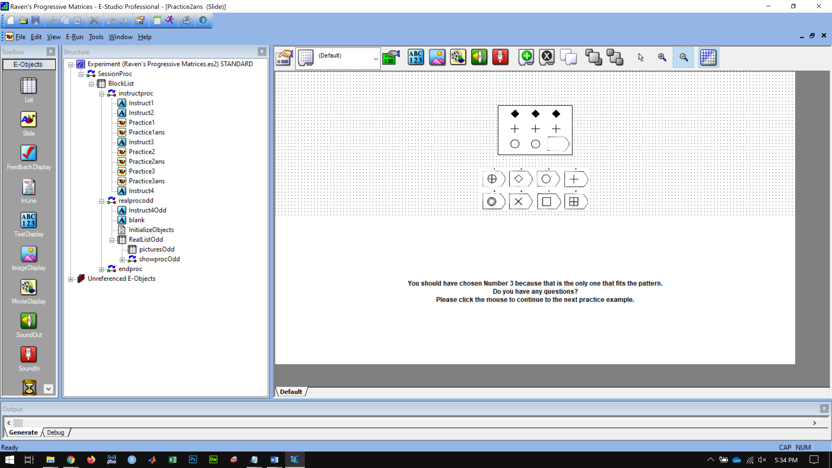

SLIDE 8

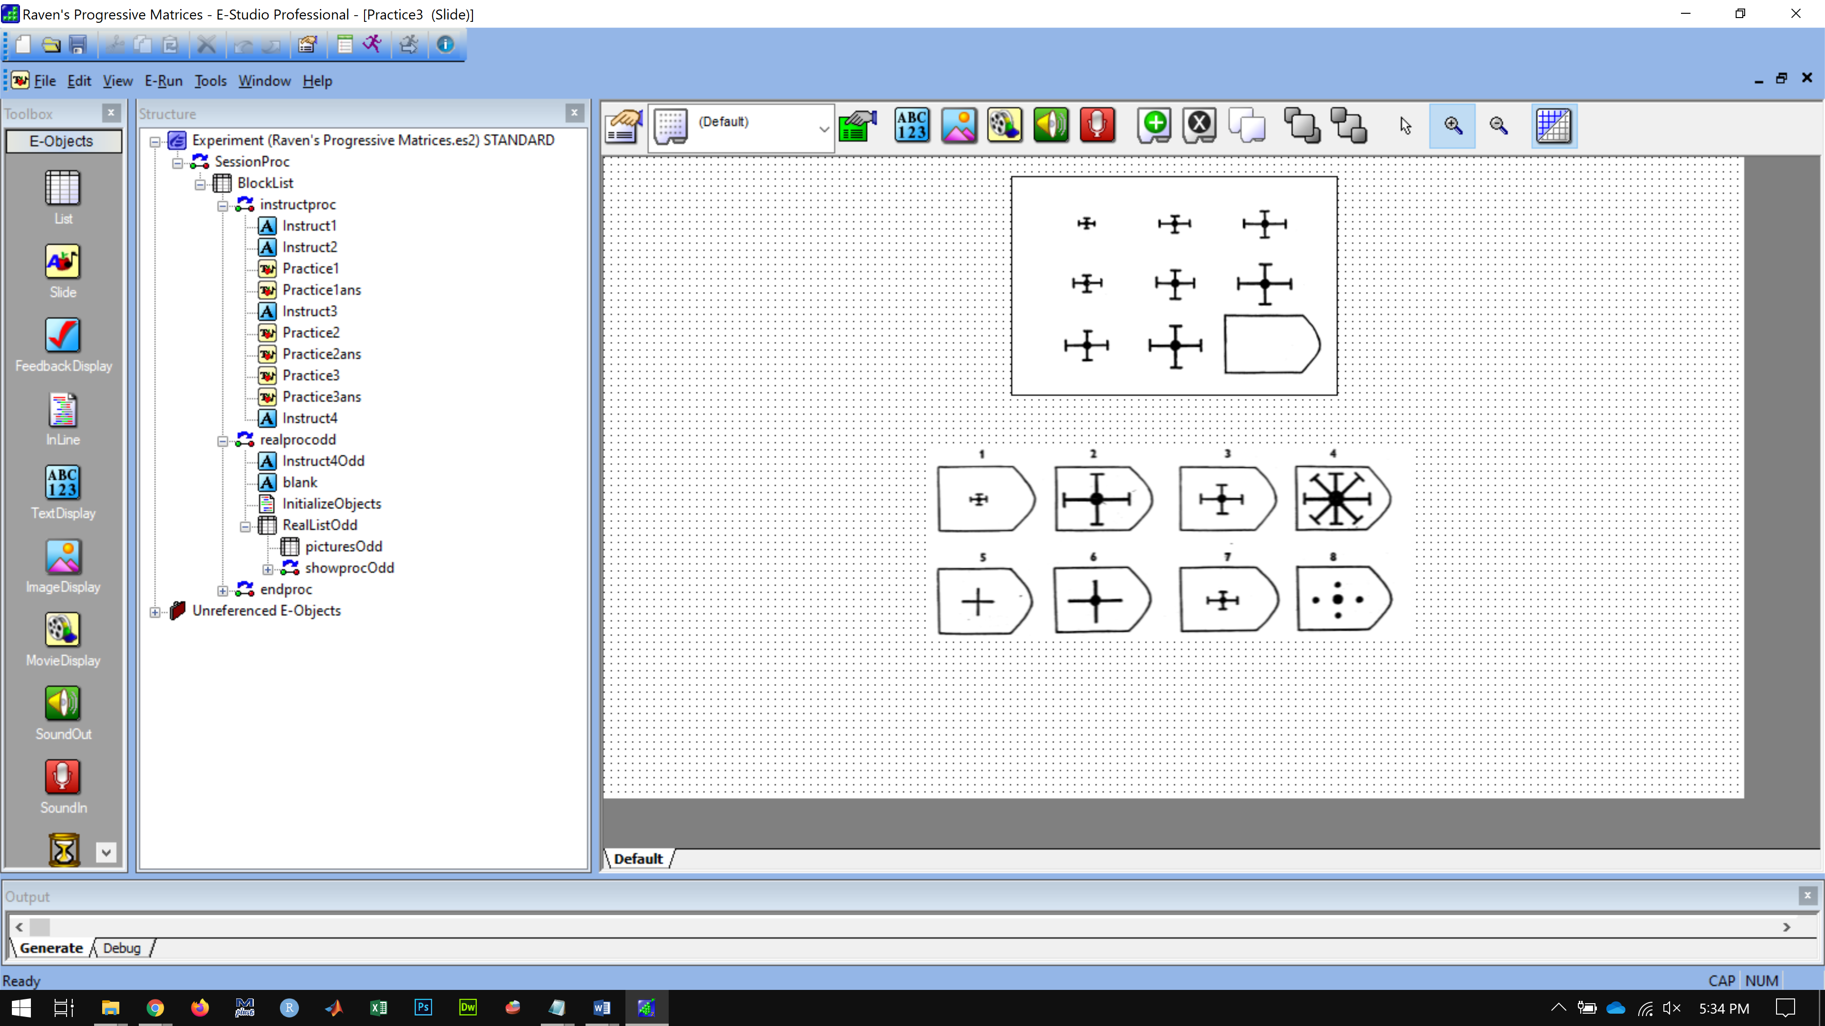

SLIDE 9

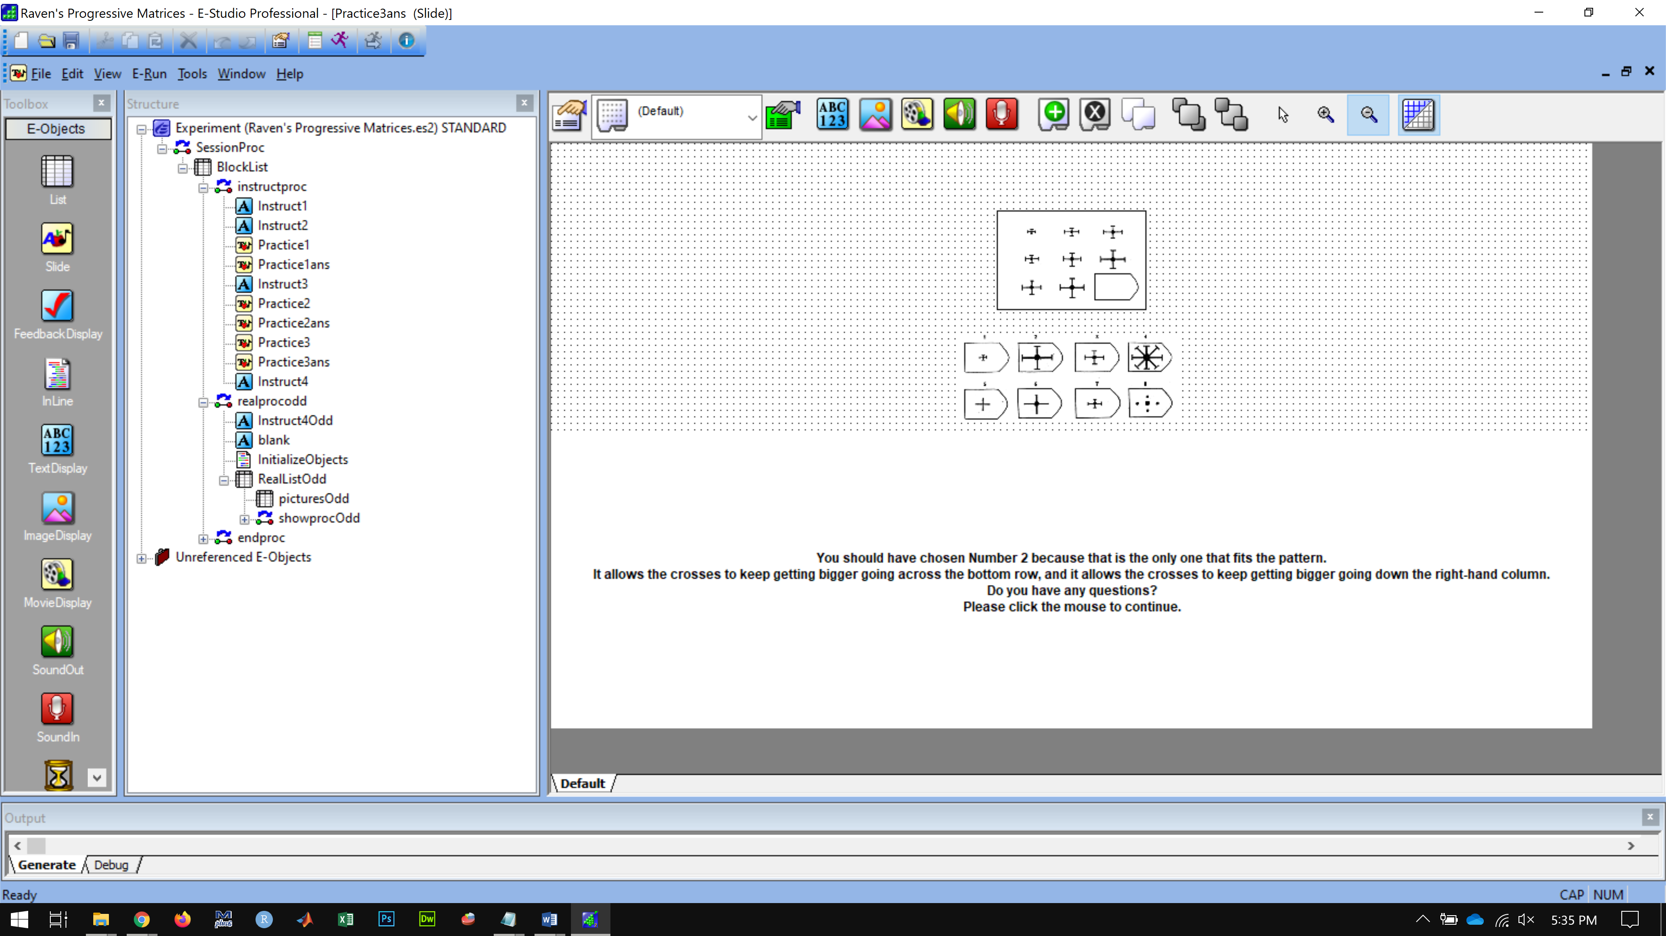

SLIDE 10

You will find the problems in this set slowly get more difficult.

In every problem you should use the same method of working.

Look along each row and decide what the missing figure is like.

Look down each column and decide again, and choose the piece you find that is right in both ways.

When you have found it, click on the answer using the mouse.

Do you have any questions?

Please click the mouse to continue.

SLIDE 11

There are 18 problems in the experiment. You have 10 minutes to complete the experiment.

You may not finish all the problems in the set before the 10 minutes, so do as many as you can. The accuracy of your work matters most. Try your best to select the correct answer for each picture before moving on to the next problem.

Do you have any questions?

Press the SPACE bar when you are ready to begin the real problems.

BEGIN TEST